**Module-1(Fundamental)**

# **Q1.What is SDLC?**

SDLC stands for software development life cycle, SDLC is a process used by the software industry to design, develop and test high quality software.

6 Stage of SDLC

* Requirements
* Analysis
* Design
* Coding
* Testing
* Deployment

**Q2.What is software testing?**

Software Testing is a process used to identify the correctness, completeness, and quality of developed computers software.

**Q3.What is agile methodology?**

* Agile is an umbrella and lots of different type fall under this umbrella
* Different type like scrum, XP and many more

**Q4.What is SRS**

* SRS is a description of a software system to be developed.
* It lays out functional and non-functional requirements of the software to be developed.

**Q5.What is oops**

* Object oriented programming

**Q6.Write Basic Concepts of oops**

* Object
* Class
* abstraction
* Encapsulation
* Inheritance
* Polymorphism
* Abstraction

**Q7.What is object**

* Any entity which has own state and behavior. Ex; any living thing pen, paper etc.

**Q8.What is class**

* Collection of objects called a class. Ex; human body

**Q9.What is abstraction**

* Hiding internal details and showing functionalities. Ex; Facebook login page

**Q10.What is encapsulation**

* Wrapping up of data or binding of data. Ex; capsule

**Q11.What is inheritance**

* When on object acquire all the properties and behavior of parent class. Ex; father-son

**Q12.What is polymorphism**

* Many way to perform anything.
* Ex; Method overloading

Method overriding

**Q13.Draw Use-case on Online book shopping**

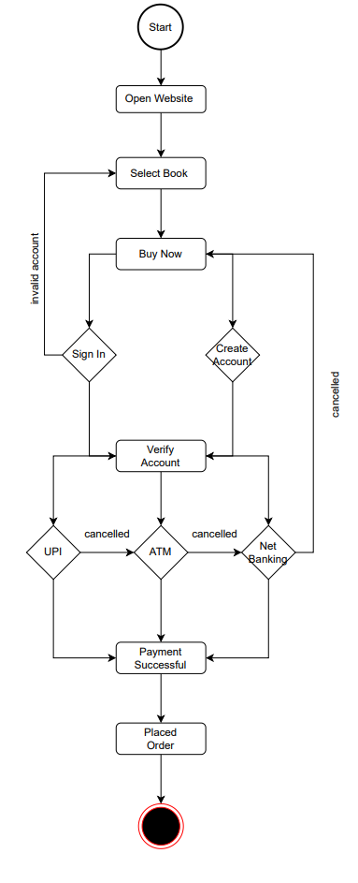

**Q14.Draw Use-case on online bill payment system (paytm)**

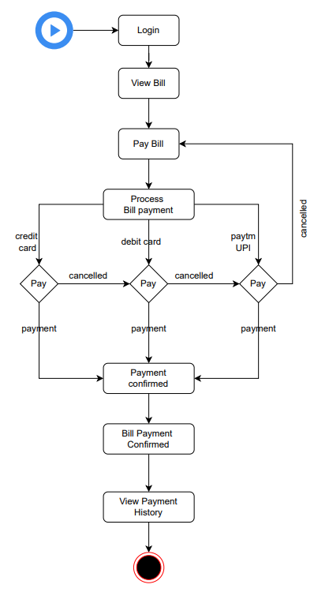

**Q15.Write SDLC phases with basic introduction**

* REQUIREMENT – planning and Requirement Analysis.
* ANALYSIS – Defining Requirements – SRS
* DESIGN – Designing the Product Architecture – data dictionaries, logical diagrams, data-flow diagrams
* CODING – Building or Developing the product - Coding
* TESTING – Testing the Product
* DEPLOYMENT – Deployment in the Market and Maintenance

**Q16.Explain Phases of the waterfall mode**

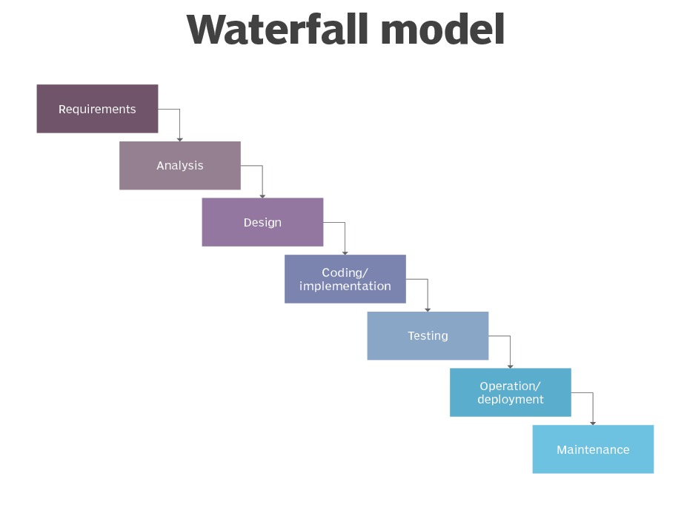

**Q17.Write phases of spiral model**

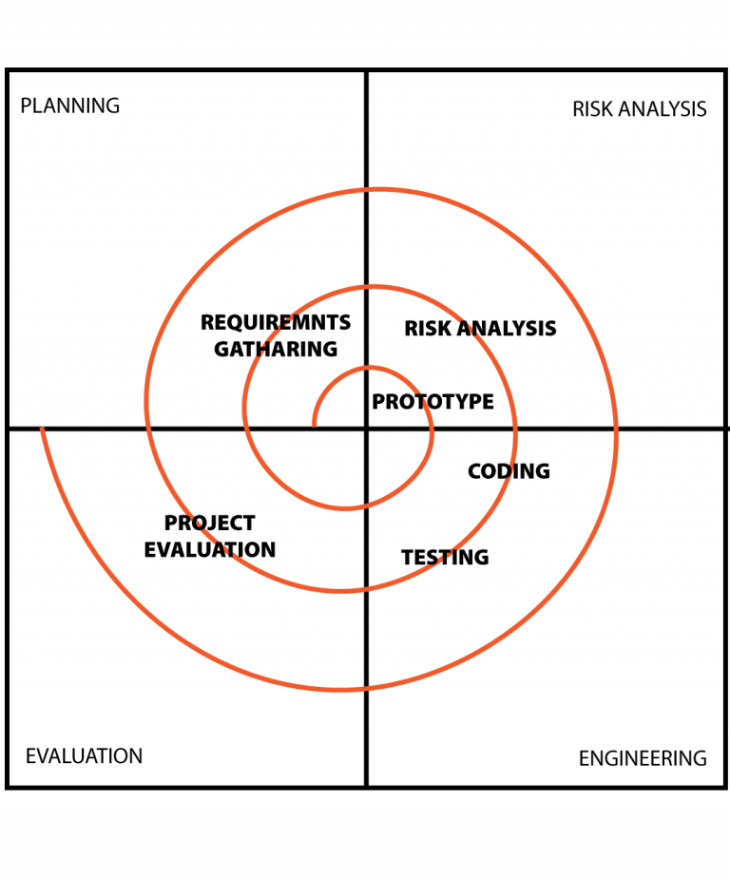

**Q18.Explain working methodology of agile model and also write pros and cons.**

* Agile works by breaking projects down into little bits of user functionality, prioritizing them, and then continuously delivering them in 1-3 week cycles called iterations of sprints.
* **Pros**
* Is a very realistic approach to software development
* Promotes teamwork and cross training.
* Resource requirements are minimum.
* Easy to manage
* Gives flexibility to developers
* **Cons**
* Not suitable for handling complex dependencies.
* More risk of sustainability, maintainability and extensibility.
* Depends heavily on customer interaction, so if customer is not clear, team can be driven in the wrong direction.
* There is very high individual dependency, since there is minimum documentation generated.

**Q19.Draw use-case on Online shopping product using COD.**

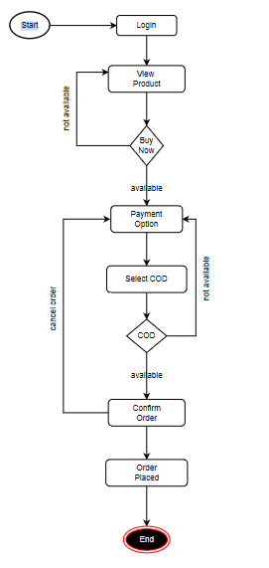

**Q20.Draw use-case on Online shopping product using payment gateway**

